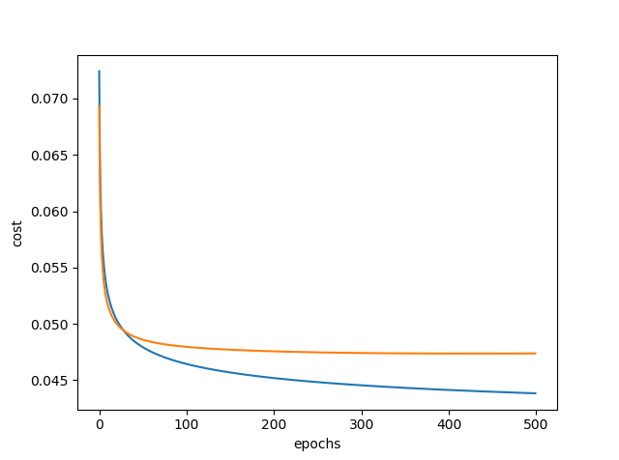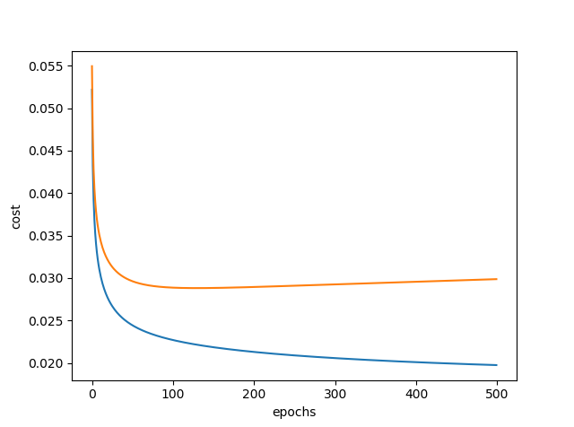

1. Losses for digit zero (0) vs. ALL (b) Losses for digit seven (7) vs. ALL